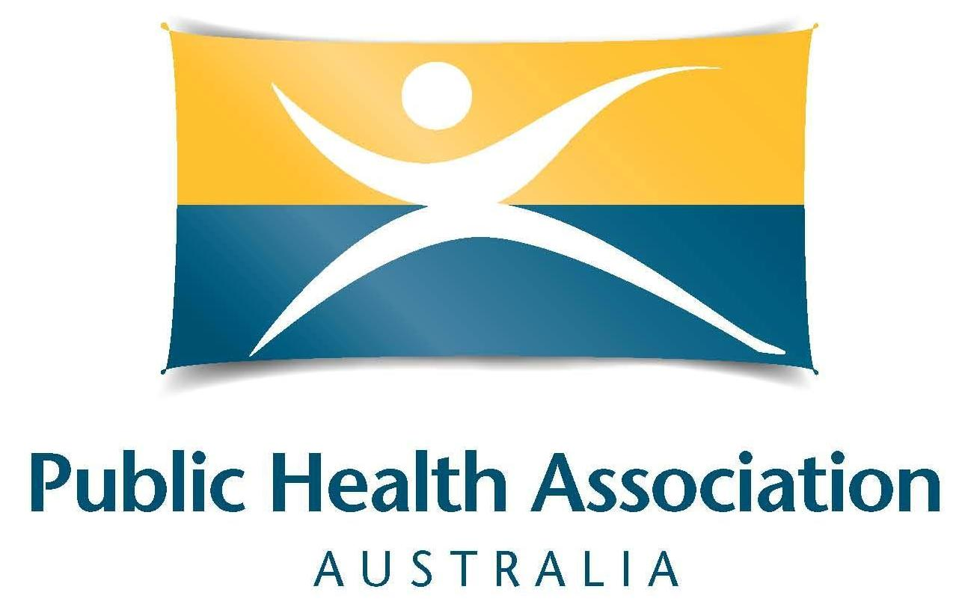
Last updated: March 2024
MEMBER
INFORMATION
PACK

Contact for PHAA:
National Office
A: 20 Napier Close, Deakin ACT 2600
E: phaa@phaa.net.au
T: (02) 6285 2373
W: www.phaa.net.au
Blog: https://intouchpublichealth.net.au

Introduction
Thank you for becoming a member of the leading national peak health body in Australia! Your membership is valued and appreciated, and we look forward to your contribution.
This pack provides a brief outline of the organisational structure, ideas on how to become involved, and other member-based information.

Public Health
The Public Health Association of Australia (PHAA) is recognised as the principal non-government organisation for public health which works to promote the health and well-being of all individuals living in Australia. The PHAA works to ensure that the public’s health is improved through sustained and determined efforts of the Board, National Office, State and Territory Branches, Special Interest Groups, and members.
The efforts of the PHAA are enhanced by our vision for a healthy Australia, and by engaging with like-minded stakeholders to build coalitions of interest that influence public opinion, the media, political parties, and governments.

Vision for a healthy population
The PHAA has a vision for a healthy region, a healthy nation, healthy people: living in an equitable society underpinned by a well-functioning ecosystem and healthy environment, improving, and promoting health for all.

Mission for the Public Health Association of Australia
As the leading national peak body for public health representation and advocacy, PHAA aims to make people healthier through increased knowledge, better access and equity, evidence informed policy and effective population-based practice in public health.

More information as outlined below can be accessed on our website:

Strategic Direction

Organisational Structure

Board

Branches - Based on your address you will automatically receive correspondence from your respective State/Territory Branch on a variety of matters

Special Interest Groups (SIGs) - There are currently 18 SIGs within the PHAA, spanning Aboriginal and Torres Strait Islander Health to Women’s Health.

SYPPH (Students and Young Professionals in Public Health)

National Office
The National Office is the secretariat of the association and provides support to members. Enquiries can be directed to the main contact details:

Membership & General Enquiries:  A: PO Box 319 Curtin ACT 2605  P: (02) 6285 2373  E: phaa@phaa.net.au | Policy Enquiries:  E: policy@phaa.net.au
Communications Enquiries:  E: communications@phaa.net.au | Events Enquiries:  E: events@phaa.net.au

Benefits of Membership

A full outline of member benefits can be found here

Membership log-in details
Your log-in details are provided at the time of registration, however it should be noted that your User Name is the email you provide at time of registration.
The password for your membership is a self-designated password you provide at the time of registration. If you have forgotten your password, a new password can be requested by choosing “forgot password” – a link to reset will be sent to your email provided at time of registration (please remember to check your spam/junk folder). If your email has changed and you have not advised us, please contact us at phaa@phaa.net.au or (02) 6285 2373 for assistance.

Renewal of membership
One month before your membership expires you will receive an email including information on how to pay online. Renewing your membership before it expires is the perfect way to make sure you do not miss out on member benefits or communication while your account is pending payment.
At the time of payment you will be able to ‘opt-in' to an automatic payment option for future renewals by simply ticking the box that states: 'Automatically pay future renewals' as shown below:
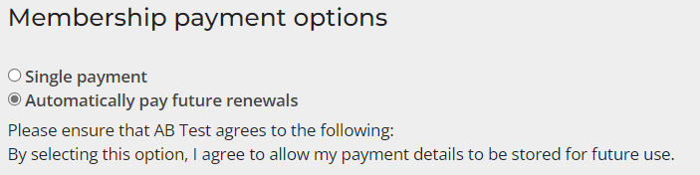
(Please be assured that any details will be held securely by our gateway provider and will not be recorded in our office, nor will be used for any other transactions)
If you have any queries, please contact us at phaa@phaa.net.au or 02 6285 2373 and we will be glad to assist.

Getting involved
PHAA membership is comprised of individuals and agencies/organisations from all walks of life. We encourage all members to become actively involved in the Association and we value your suggestions. Below are a range of other ways to get involved as a volunteer for the organisation, and to participate in advocating for public health issues in Australia.

Policy Position Statements
Help update our PHAA Policy and Position Statements, which are reviewed every three years We explain the review cycle and call for assistance via our members’ only Pump newsletter, and emails.

Submissions
If you are interested in contributing to a submission or you would like PHAA to have input on a specific committee, please get in touch via policy@phaa.net.au.

Events
Members can engage in events such as speaking opportunities (through a call for abstracts), abstract reviews, volunteering prior to events through committees, assisting with onsite logistics during the event, and sponsorship and exhibition opportunities. The PHAA Events Team invites emails, events@phaa.net.au

The Pump
Our exclusive weekly newsletter is sent to members every Thursday afternoon. It contains a summary of the latest public healthy news in Australia and abroad, including activities of the association’s national and state/territory operations, and also job listings and other opportunities. We welcome contributions of 100 words or less by COB Wednesdays to mailto:communications@phaa.net.au

Intouch public health blog
This is a unique platform for the Association and its members to promote research and advocacy work, inform public debate, share expert opinion and communicate more broadly. All PHAA Australia members are invited to contribute to Intouch in areas in which they have expertise.

Social Media
PHAA maintains seven social media accounts, including Twitter, LinkedIn, and Instagram

